Job Description / Specification
Job Title: | Site Survey & support Engineer
Reporting To
Job Title: | Relight Service Manager
Location
Department: | Relight Project Service Team
Organisation Structure
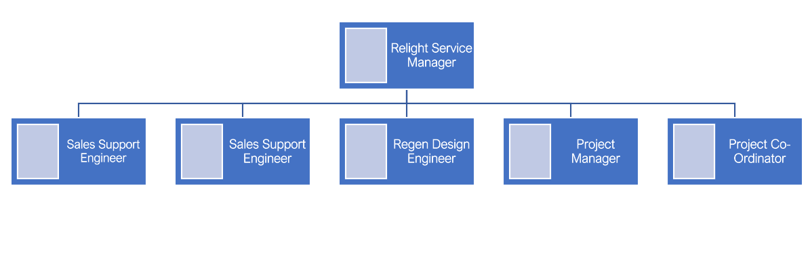
Site Survey & Support Engineer

Purpose of the Position
To ensure Whitecroft provide an efficient premium Pre-Order Survey & Design service to our Sales team and clients on Relight Projects.

Key Responsibilities
1 | To ensure the smooth and effective operation of Whitecroft’s Lighting Survey and design process. To liaise with Whitecroft Account Managers, providing technical support and validation of proposals when called upon.
2 | To effectively manage the flow of Survey data between teams, ensuring excellent communication methods are utilized, meeting/exceeding customers’ requirements and expectations.
3 | Undertaking Lighting Surveys on customers sites using iPad Survey Data collection Software.
4 | Provide Lighting Survey support / training to colleagues and third-party contractors.
5 | To manage the input and output of all survey data, from preparing drawings at the start of the process through to the re-formatting the survey data and handover to the Lighting Designers at the end of the process.
6 | Ensure projects are completed according to plan schedules, company policy and quality standards.
7 | Coordinate site visits, liaising with customers and surveyors to ensure efficient use of time and resources.
8 | Keep the Operations Manager and colleagues informed on status of all assigned projects and tasks.
9 | Represent Whitecroft Lighting in a professional manner, with well-composed correspondences.
10 | Provide onsite Standard & Custom design installation support in collaboration with the sales team and clients on Relight projects, providing design & technical support/guidance on lighting and controls
11 | Continuously identify and effectively communicate ways to improve the Relight service.

Specific Skill Requirements
 | Essential | Desirable
Education / Technical Skills | - Knowledge & experience of working within the lighting industry, including knowledge of our products.  - Must have knowledge of a variety of computer software applications such as CAD, word processing, spreadsheets, and database software.  - Experience of dealing with customers face to face.  - Full UK Driving Licence. | - Outdoor lighting experience  - Demonstrable experience of using Relux / Dialux and Auto CAD  - Experience of Revit / BIM  - Experience in Payback / ROI / Energy Calculations.  - Be a CSCS ECS Trade Card Holder to enable work on Construction sites  - experienced time served Electrician or Electrical Engineer within the Retail, Educational, Commercial, and Industrial sectors.  - Electrical engineering Qualification.
Behaviour | - Strong ability to manage multiple projects at the same time.  - Excellent interpersonal skills & promotes collaborative working; with the ability to work with key stakeholders at all levels.  - Excellent communication skills, both written and face to face, with the ability to be clear when delivering technical information.  - Is effective in planning and organising workload to ensure timely achievement of tasks.  - Attention to detail.  - A problem solver with decisive decision making. | - Ability to anticipate the potential areas of conflict, with the ability to manage/diffuse situations effectively.

Document Management
Written By: | John Earley | Date: Nov 2023

