c

Job Description / Specification

Job Title: | Assembly Resource Lead
Reporting To
Job Title: | Manufacturing Manager
Location
Department: | Operations
Organisation Structure
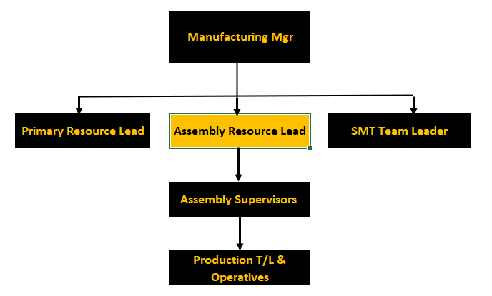
Purpose of the Position
To improve and drive the factory manufacturing Assembly process to deliver industry best timescales, whilst improving factory efficiency, quality and reducing operational costs.

Key Responsibilities
1 | Have full ownership of Production Assembly capacity and production work centres
2 | Champion of change to deliver industry best manufacturing lead times
3 | Execution of the daily production
4 | To lead the introduction of Continuous Improvement projects which will improve quality, reduce production lead-times, enhance manufacturing flexibility and reduce costs
5 | To actively manage labour costs, material scrap, expendables to maximise gross Manufacturing Efficiency and Operational performance
6 | Develop a continuous improvement culture in the Assembly manufacturing team
7 | Engage directly with other functional areas such as Design, Technical and Engineering
8 | Ensure that planning parameters including work-centre capacities are reviewed to ensure bottlenecks in capacity are identified and eliminated
9 | Develop and own appropriate departmental KPI’s to ensure performance and improvement is measured and acted on
10 | To manage, support and develop through training, mentoring and skills management the Cell Leaders and Productions teams to ensure effective performance
11 | Ensure Health and Safety practices are followed at all times

Specific Skill Requirements
 | Essential | Desirable
Education / Technical Skills | - Leadership qualification or equivalent in experience.  - Demonstrable experience in managing, leading and developing a production team of 100+ direct employees  - Experience of working within a fast paced manufacturing environment, preferably within a company with a turnover between £25M and £100M producing high variety, mid volume, electrical products where reliability of supply and rapid response is critical.  - Experience of delivering results against operational, service, quality, safety and cost targets  - Demonstrate a strong understanding of Production flow methodology  - Practical experience of Lean fundamentals and continuous improvement within manufacturing  - Ability to collate and analyse data to put together production reports  - Strong IT literacy | - Recognised qualifications Operations management based  - Degree level in an Engineering Discipline
Behaviour | - Lateral thinker and problem solver using appropriate tools and techniques  - Ability to listen to views of a variety of stakeholders and acting appropriately  - Strong leader with good interpersonal skills with the ability to motivate others to meet deadlines  - Have a results-driven approach to work  - Ability to work in a logical, systematic manner  - Ability to communicate clearly and persuasively with your team, managers and customers  - Ability to act decisively to solve problems/issues to “make things happen”

Document Management
Written By: | Robert Bates | Date: Oct 2021

