c

Job Description / Specification

Job Title: | Controls Support Engineer
Reporting To
Job Title: | Controls Manager
Location
Department: | Commercial
Organisation Structure
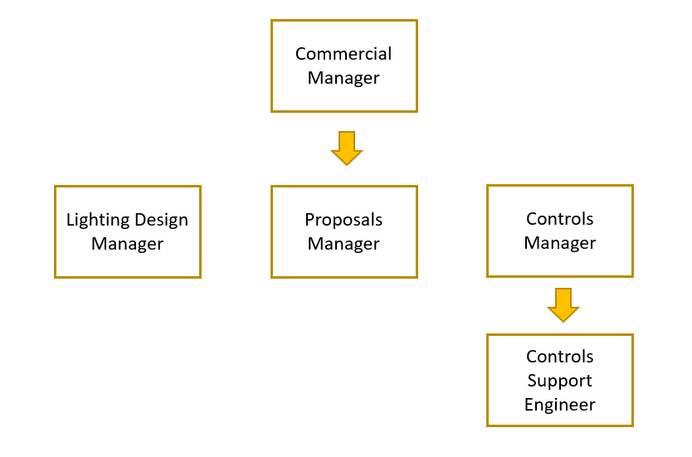

Purpose of the Position
Deliver exceptional internal and external customer support throughout the sales cycle for lighting control technologies

Key Responsibilities
1 | Provide remote technical project/product support for all lighting control technologies to primarily external customers and the sales team
2 | Interrogate project specifications and articulate the appropriate product solution to adhere to the specification
3 | Support the sales cycle at tender stage through estimating support and the development of the estimating tools to enhance customer service
4 | Liaise with the appropriate stakeholders to understand and agree the lighting controls design principles prior to the detailed lighting and controls design stage
5 | Support external stakeholders through the design interpretation and quantification of a compatible lighting control solution utilising Whitecroft’s existing product offer
6 | Deliver consistency and share best practice to improve accuracy. Share knowledge and support through formal & informal training with the intention of increasing lighting controls penetration within core projects
7 | Communicate with the supply chain to ensure product functionality will meet the performance specification
8 | Support customers to achieve their design ambitions through collaboration along with an understanding of the practical and commercial landscape

Specific Skill Requirements
 | Essential | Desirable
Education / Technical Skills | - Experience of working with wired and wireless lighting controls in the built environment or experienced lighting and controls design engineer | - Understanding of BMS integration  - Electrical installation or Electrical Engineering background
Behaviour | - An enthusiastic team player with an ability to build effective relationships with multiple stakeholders across the business  - Strong communication and presentation skills with the ability to problem solve  - Customer focused with the ability to react quickly to change in customer demand  - Ability to demonstrate a high level of organisation skills to ensure deadlines are achieved  - Proactive in the development of new and intuitive ideas to improve customer service

Document Management
Written By: | Andrew Braithwaite | Date: September 2021

