Job Description / Specification

Job Title: | Design Engineer
Reporting To
Job Title: | Design Manager/ Senior Design Engineer
Location
Department: | NPD
Organisation Structure
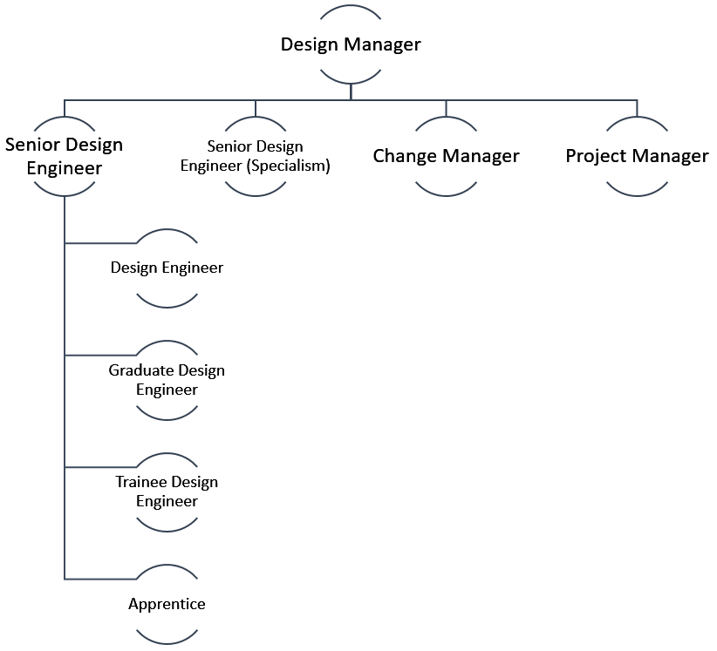
Purpose of the Position
Working closely with the Senior Design Engineer create innovative, robust and sustainable design solutions following best engineering design principles. Key to delivering the business strategy and exceed customer’s needs.

Key Responsibilities
Complete medium scale complex projects in strict adherence to the requirements of the NPD Gate process.
Design and develop a product/solution that meets all aspects of the project specification within required timescale.
Demonstrate clear understanding and effectively communicate the rationale behind project specifications, challenging requirements where necessary.
Deliver effective and commercially viable design solutions with the help of FMEA ensuring the safety and reliability of all products.
Accurately complete all relevant documentation to support all design solutions.
Use appropriate design tools (i.e. sketches, hand-made models, prototypes and 3D CAD) to help communicate solutions clearly and efficiently.
Create accurate CAD, ERP and PLM data following best practice.
Create accurate costed bill of materials for all new product design.
Review any cost drift when identified determining a solution to reduce costs and ensure communication to all key stakeholders.
Produce production capable components and assemblies. Performing research on product technologies and structures to implement into design concept.
Continuously improve on existing production designs and processes where possible, identifying and effectively implementing any improvements.
Continuously review product installation methodologies creating innovative solutions with supporting samples and installation leaflet. Ensuring a safe and easy experience for our customers.
Identify and resolve problems by following a process to determine root cause. Implementing corrective action that ensures the problem does not return.
Maintain up to date knowledge on current industry trends and market conditions
Commercially aware of competitors products and remain up to date on market trends.

Specific Skill Requirements
 | Essential | Desirable
Education / Technical Skills | - A degree in a relevant engineering or science discipline or equivalent.  - +2yrs industry experience delivering products from concept to customer. Delivering robust design solutions on time, to specification and within cost and budget constraints.  - Experience of creating 3D CAD following best practice guidelines, engineering drawings and tolerance stacks for mechanical/electrical components and assemblies along with test rigs and assembly jigs.  - Good level of understanding of Microsoft office namely Excel and PowerPoint.  - Experience of applying practical tools (sketch, calcs, handmade, 3D prototypes) to create fit for purpose prototypes for test purposes and review.  - Sound understanding of mechanical and physical principles.  - Ability to drive development of products and technologies through prototyping and testing.  - Understanding and practical application of design wheel / design processes.  - Good knowledge and understanding of multiple tooling and manufacturing techniques. | - Use of FEA tools to develop concepts with consideration for material failure.
Behaviour | - Effective communication.  - Interpersonal / Team work.  - Organisation.  - Problem Solving.  - Adaptability.  - Effective Leadership.

Document Management
Written By: | Jack Johnson | Date: January 2021

