Job Description / Specification

Job Title: | Graduate Sales Engineer
Reporting to: | Regional Sales Manager
Department: | Sales
Organisational Structure
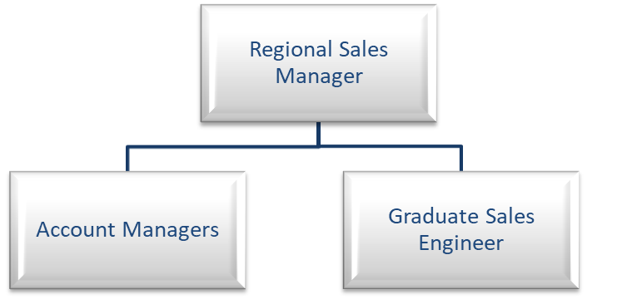
Purpose of the Position
The 18 month development programme will provide knowledge and experience to be a successful member of the sales team by:

Achieving the maximum profitable sales through the achievement of order intake and sales targets, motivating customer commitment, adherence to agreed KPI’s, building value additive relationships with customers and by making new and existing customers aware of the company’s product portfolio.

Key Responsibilities
- To achieve the agreed target through the support of Architects, Consultants, End Users and Contractors, that Whitecroft Lighting products are specified and installed in Specification lead projects.
- To maximise the market penetration within the designated client base to achieve a year-on-year growth in market share, whilst striving to maintain and grow current margin expectations.
- Implement sales and marketing activities to grow the revenue and profitability within key M & E contractors & consultants.
- Manage lighting projects from conception / specification, through to completion so as to ensure maximum benefits to the company with minimum disruption.
- Work within and support frameworks and utilise and follow up supply chain information.
- Proactively plan and manage appointments to existing and potential new clients.
- Proactively respond to any sales / order enquiries.
- Manage and develop relationships with existing and new customers through planned individual account support.
- Work in collaboration with internal teams – Customer Service, Commercial, Marketing and Technical.
- Develop and seek new business opportunities.
- Demonstrate sample products and launch new products and present the associated marketing collateral.
- Prepare accurate reports detailing the sales activity, opportunities and market conditions.
- Regularly maintain accurate records on the dedicated company CRM system
- Maintain product and controls knowledge through attendance at internal product training sessions.
- Support and work as a team with field-based colleagues

Specific Skill Requirements
 | Essential | Desirable
Education / Technical Skills | - Educated to degree level  - Experience of working in a customer facing environment  - Strong IT skills  - Driving license
Behaviour | - Effective communication skills both written and verbal.  - Demonstrate ability to work in an organised manner that enables achievement of projects within a required timescale.  - Is self-motivated but works well within a team.  - Delivers a high quality standard of work that ensures it meets the needs of the customer.  - Demonstrates strong negotiation skills.  - Demonstrates ability to be customer focused.  - Demonstrates a high level of resilience with the ability to stay focused, remaining calm when under pressure.

Written By: | Jayne Baker | Date: July 2022

