c

Job Description / Specification

Job Title: | Health Safety / Sustainability Officer
Reporting To
Job Title: | Business Improvement Manager
Location
Department: | Business Improvement
Organisation Structure
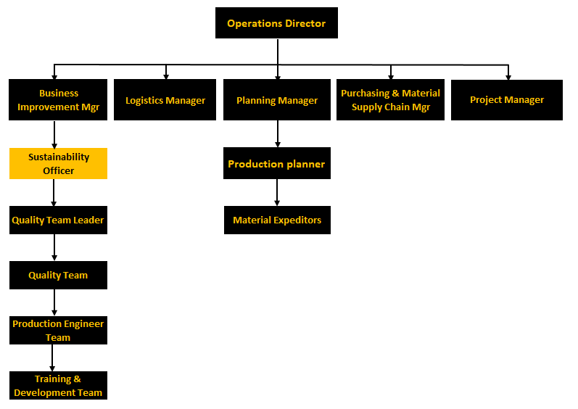

Purpose of the Position
To ensure safe and effective control of all activities across the site so as to meet and exceed Health, Safety, Sustainability and environmental expectations and legal requirements.

Key Responsibilities
1 | Ensuring, Health, Safety, Environmental legal compliance on all processes, advising upon best practice and effective implementation methods to meet new requirements.
2 | Achieve and maintain ISO 45001 approval and management system, ensuring its continued integration with our Quality and HSE processes.
3 | Monitoring and auditing processes against HSE requirements, reporting on variances and working with the site team to ensure effective solutions are acted open.
4 | Leading by example, driving a culture of best practice and personal ownership towards Health and safety.
5 | Communicating with and demonstrating effective HSE controls to customers and regulatory visitors or assessors.
6 | Working effectively with all our staff to improve HSE practices, coordinating and participating in effective risk assessments.
7 | Auditing all processes and activities to ensure they have suitable and sufficient risk assessments for HSE aspects and ensuring effective communication and control systems are in place to address the highlighted risks.
8 | Ensuring effective control & records of packaging waste are maintained by site staff, enabling accurate annual validation of volumes of waste. Collation of the results and declaration to VALPAK in order to comply with the requirements of the packaging waste regulations.
9 | Ensuring effective implementation of controls to meet requirements of the waste electrical equipment legislation.
10 | Ensuring effective customer communication over environmental issues (such as ROSHH, WEEE, REACH).
11 | Support for and involvement in the development of all management and staff with regard to improving all aspects of HSE related activities.
12 | Delivering the effective transition and cultural step change to attaining a business Health and safety compliance and accreditation of ISO 18001
13 | Driving a sustainability culture and business wide sustainability plan.

Specific Skill Requirements
 | Essential |  | Desirable
Education/  Technical Skills | - HNC or equivalent in engineering / manufacturing operations.  - NEBOSH, National Diploma in Occupational Health and Safety.  - Qualified lead auditor for purposes on maintaining Health, Safety and environmental controls.  - Strong IT skills, particularly in Microsoft Excel and Word  - High level of numeracy |  | - 5 years Health and Safety background  - Managed a Health and safety program to attain ISO 18001  - Back ground of working in a Fast paced Manufacturing industry, with short delivery timescales and high number of production SKU’S.  - MIOSH (Member of the institution of Occupational Safety and Health.)  - AIEMA (Associate Membership of Institute of Environmental Management and assessment.
Behaviour
Health, Safety & Environment |  | Takes responsibility for health, safety & environmental requirements and standards, under qualified guidance develops systems and processes to ensure compliance and minimised risks.
Change Management |  | Ability to understand and apply sound principles for the transition from one state to another in a planned and orderly manner, ensuring support and commitment of those involved
Team Working |  | Works cooperatively and effectively with others in a team to achieve shared objectives: recognises and works in collaborations with all functions within the business.
Commitment to Results |  | Works in a focussed, committed and purposeful way, taking responsibility for actions; successfully overcoming obstacles to deliver timely high quality results
Communication |  | Communicates information reliably, both oral and written, in a clear accurate and concise manner taking into account the needs of the recipient. Communicates effectively with senior management.
Adaptability/  Flexibility |  | Ability to take on new tasks, adopting a flexible approach in order to reach goals and to maintain effectiveness within changing environments and with varying responsibilities
Problem Solving |  | Effectiveness in identifying problems, seeking relevant data, recognising important information, diagnosing root cause and taking appropriate actions to rectify problem
Planning/  Organising |  | Able to allocate time and co-ordinate resources effectively for timely completion of tasks and projects. Anticipating obstacles and developing contingency plans
Dependability/  Reliability |  | Sets and demonstrates high level of reliability and dependability both in working hours and timeliness of meetings
Professional Approach |  | Passionate about the business, striving to improve, looking for solutions; professional, determined, friendly and courteous in their approach

Document Management
Written By: | Alex Gibbons | Date: June 2021

