c

Job Description / Specification

Job Title: | Manufacturing Manager
Reporting To
Job Title: | Operations Director
Location
Department: | Operations
Organisation Structure
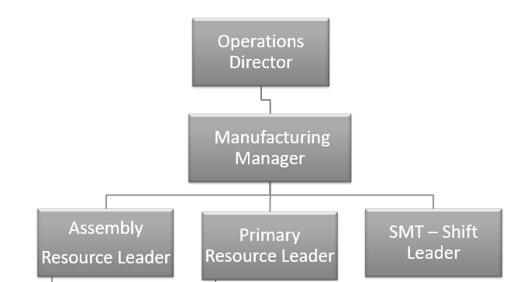

Purpose of the Position
To ensure the manufacturing facility enables the business to achieve growth by becoming the industry’s quality supplier of choice with a cost-effective range of product designed and built to the highest standard at the lowest possible cost in the shortest lead-time.

To build on the company’s strategy for improved quality, product cost, productivity and flexibility by managing and improving the production manufacturing processes and production team.

Key Responsibilities
- Full ownership of the production manufacturing capacity and production work centres and execution of the Manufacturing production plan.
- Ensure planning parameters, work centre capacities are reviewed to ensure bottlenecks in capacity are identified and eliminated.

- To lead and drive the introduction of continuous improvement projects which will improve quality, Health and safety, reduce production lead times, enhance manufacturing flexibility and reduce costs.
- Actively manage labour costs, material scrap, expendables to maximise gross manufacturing efficiency and operational performance

- Act with passion as the champion of change to deliver industry best manufacturing lead times and on time in full deliveries.

- Develop and drive a continuous improvement culture in the manufacturing team.
- Develop and drive behavioural change towards Health and Safety and quality assurance.

- Engage directly with other functional areas such as commercial, technical, quality, production engineering to develop cross functional relationships and improved communication.

- Develop and own appropriate departmental KPIs to ensure performance and improvement is measured and acted upon.

- Manage and develop through training, mentoring and skills management the manufacturing Supervisors and cell leaders to ensure effective performance.

Specific Skill Requirements
 | Essential | Desirable
Education/  Technical Skills | - Min. 3 years working in a fast-paced manufacturing facility in a production management role.  - Recognised qualifications in Leadership / Operations management  - Detailed knowledge of Lean Manufacturing principles  - Strong IT skills.  - Experience of improving on time delivery, lead time reduction and effective inventory control.  - Demonstrate a measurable history of delivering improved on time delivery, high quality yield, high levels of production efficiency improvements.  - Strong analytical skills with the ability to analyse data to advise and compile proactive action plan for improvement activities.  - Good understanding of the commercial and business implications of failure to deliver quickly and on time. | • Degree Level preferably in an engineering discipline.  - SAP – ERP functionality.
Behaviours | - Strong leadership skills with ability to effectively lead and manage teams to ensure an effective service is provided to the business.  - Demonstrates good interpersonal skills with ability to build strong relationships with key stakeholders  - Works and drives collaborative working  - Lateral thinker and problem solver ability to apply appropriate tools and techniques.  - Strong communication skills both in verbal and written format  - Willing to ‘roll up sleeves’ and ‘get stuck in’.  - Ability to influence key stakeholders  - Display high levels of resilience during busy periods

Document Management
Written By: | Robert Bates | Date: 15/09/2021

