c

Job Description / Specification

Job Title: | Planning Manager
Reporting To
Job Title: | Operations Director
Location
Department: | Operations
Organisation Structure
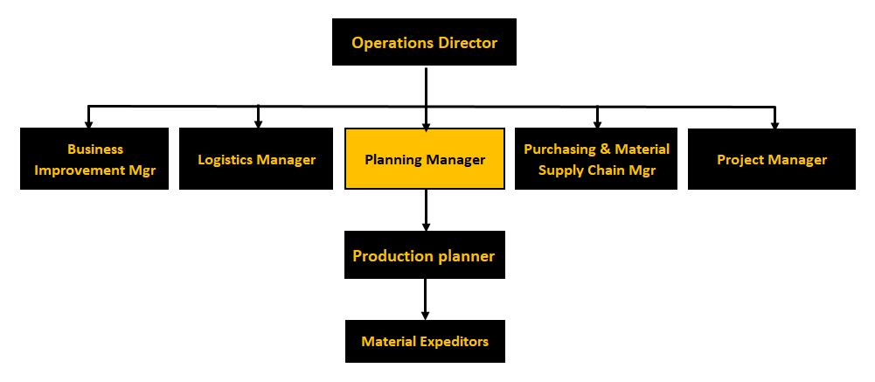

Purpose of the Position
To build on the company’s strategy to deliver industry best lead times and on time delivery in full. Whilst managing inventory levels and factory efficiency for the business, assisting in the continued drive for growth by becoming the industry’s supplier of choice.

Key Responsibilities
- Act with passion as the champion of change to deliver industry best manufacturing lead times and on time in full deliveries.

- To introduce and lead a formal Sales and Operations planning process. Identifying a supply and demand plan.

- To lead the necessary changes to factory planning and materials planning processes and methods.

- To lead the simplification project to transfer the current ERP planning system from MATP /CTP to ATP – Lead time Scheduling, and other major project level changes to the company’s existing ERP system.

- To actively manage inventory levels to maximise customer service whilst also paying due regard to obsolescence and cash management.

- Analysis the performance of the Manufacturing and supplier performance to drive continuous improvement.

- Develop a continuous improvement culture in the Planning and Manufacturing team.

- Engage directly with other functional areas such as commercial, technical and production.

- Ensure that ERP materials parameters including, Min, Max, Mults, MOQ, stocking and policy settings etc are maintained and set to appropriate levels.

- Ensure that planning parameters including workcentre capacities, move and queue, batch size and workcentre groupings are reviewed and amended as appropriate

- Develop and own appropriate departmental KPIs to ensure performance and improvement is measured and acted upon.

- To manage and develop through training, mentoring and skills management the planning and materials control teams to ensure effective performance.

- Drive a culture within the planning team to own the production plan.

Specific Skill Requirements
 | Essential | Desirable
Education/  Technical Skills | - Degree Level preferably in an engineering discipline.  - Recognised supply chain qualifications  - Detailed knowledge of supply chain practice.  - Strong IT skills – advanced level of Excel  - Experience of improving on time delivery, lead time reduction and effective inventory control.  - Detailed knowledge of working and driving the most out of ERP systems  - Strong analytical skills with the ability to analyse data to advise and compile proactive action plan for improvement activities.  - Good understanding of the commercial and business implications of failure to deliver quickly and on time; links to inventory management. | - 5 years Planning management experience.  - Experience of working in a Fast paced Manufacturing industry, with short delivery timescales and high number of production SKU’S.  - SAP – ERP functionality.
Behaviours | - Strong leader skills with ability to effectively manage planning team to ensure an effective service is provided to the business.  - Demonstrates good interpersonal skills with ability to build strong relationships with key stakeholders  - Lateral thinker and problem solver ability to apply appropriate tools and techniques.  - Strong communication skills both in verbal and written format  - Willing to ‘roll up sleeves’ and ‘get stuck in’.  - Ability to influence key stakeholders  - Display high levels of resilience during busy periods

Document Management
Written By: | Robert Bates | Date: 03/06/2021

