c

Job Description / Specification

Job Title: | Project Support Coordinator
Reporting To
Job Title: | Customer Services Team Leader
Location
Department: | Customer Services
Organisation Structure
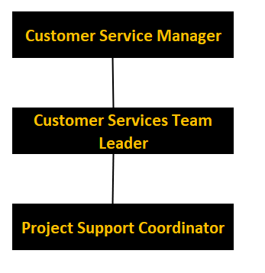

Purpose of the Position
To act as the primary business interface for customers and the external sales force providing a full range of support services, predominantly dealing with mid-level projects that are of a higher value. An essential function of the role will be ensuring a smooth end to end customer journey from the point of order to complete service delivery.

Key Responsibilities
1 | Take incoming calls and emails for all enquiries, ranging from pricing queries to delivery information ensuring an accurate and timely response to these queries.
2 | Managing projects and customers through their journey with Whitecroft Lighting ensuring a complete and full project is delivered on time with minimal issues.
3 | Support all customers regionalised from a specific area and work closely with those sales area managers to provide best in class service to both internal and external customers.
4 | Arrange & lead meetings with customers and sales engineers to carry out handover meetings and project updates. This is usually done on Microsoft Teams or sometimes on site with the customer.
5 | Offer consistent levels of support across the wider business.
6 | Ensure effective communication to all stakeholders, internal and external customers throughout the duration of the project, providing timely updates to the customer and acting on any issues that have been identified.
7 | Provide annual leave cover and support to other roles within the department ensuring a continuation of the service provided to customers, both internal and external.
8 | Continuous management of the order book to identify and rectify potential issues before they can cause further challenges or delays to the project.
9 | Support management with continuous improvement activities to enhance the service levels to both internal and external customers.
10 | Liaise with other departments to ensure complete business visibility of the customer journey and work with them to resolve any potential issues that may impact the service delivery.
11 | Identify and manage risks to ensure delivery is on time.
12 | Provide project updates on a consistent basis to various stakeholders including management and internal and external customers regarding the progress of the project, raising if for any reason the project is projected to be behind target.

Specific Skill Requirements
 | Essential | Desirable
Education / Technical Skills | - Have gained a minimum of 2 years’ experience of working within a customer service environment.  - Demonstrate experience of offering excellent service to customers in a busy, fast paced environment.  - Experience of working within an administration or order processing role.  - IT literate – able to use Microsoft Office programs including word, outlook and excel.  - GCSE Maths & English minimum grade 4 (C) or equivalent. | - Experience of working within a manufacturing industry.  - Experience of Project Management.  - SAP experience.  - Business to Customer (B2C) experience.
Behaviour | - Demonstrates exceptional customer service skills  - Effective communication skills in both verbal and written format.  - Demonstrate high levels of resilience with the ability to meet deadlines when under pressure.  - Demonstrates ability to work well within a team and apply own initiative to ensure a task is completed.  - Show flexibility in order to meet the demands of business needs as they arise sometimes at short notice.  - Is organised to ensure day to day tasks are completed within a timely, accurate and professional manner.  - Demonstrates a passion for continuous self and business improvement. | - Willingness to up-skill and enhance knowledge through any training requirements.

Document Management
Written By: | Joanne Burrows | Date: 04/01/2024

