c

Job Description / Specification

Job Title: | Commercial Support Coordinator
Reporting To
Job Title: | Commercial Support Team Leader
Location
Department: | Commercial Support
Organisation Structure
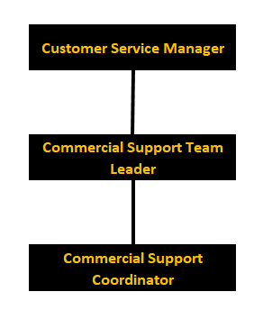

Purpose of the Position
To provide the primary internal business interface for customers and the external sales force. Providing a full range of support services including pricing information, lead time enquiries and pro-active management of orders. To answer and respond in inbound calls and emails in a professional and timely manner.

Key Responsibilities
1. | Take incoming calls and emails for all enquiries, ranging from pricing queries to delivery information.
2. | Proactively inform customer of delivery dates and any changes or delays to delivery days.
3. | Manage and process sales orders from a specific area and work closely with those sales area managers to provide best in class service.
4. | Offer consistent levels of support across the wider business.
5. | Offer annual leave cover and support to other roles within the department.
6. | Continuous management of order book to find potential issues and rectify before they cause further challenges.
7. | Liaise with other internal and external departments to ensure complete business visibility of customer journey.

Specific Skill Requirements
 | Essential | Desirable
Education / Technical Skills | - Experience of working within a customer service environment.  - Experience of working with an administration and order processing role.  - IT literate – particularly within Microsoft Office.  - GCSE Maths & English or equivalent | - Experience of working within a manufacturing industry.  - SAP experience
Behaviour | - Demonstrates exceptional customer service skills  - Effective communication skills in both verbal and written format.  - Demonstrate high levels of resilience with the ability to meet deadlines when under pressure.  - Demonstrates ability to work well within a team and apply own initiative to ensure a task is completed.  - Show flexibility in order to meet the demands of business needs as they arise sometimes at short notice.  - Is organised to ensure day to day tasks are completed within a timely, accurate and professional manner.  - Demonstrates a passion for continuous self and business improvement. | - Willingness to up-skill and enhance knowledge through any training requirements.

Document Management
Written By: | Lucy Dawber | Date: 15/01/2022

