Job Description / Specification

Job Title: | Marketing & Campaign Executive
Reporting to: | Marketing Manager
Department: | Marketing & Product Department
Organisational Structure
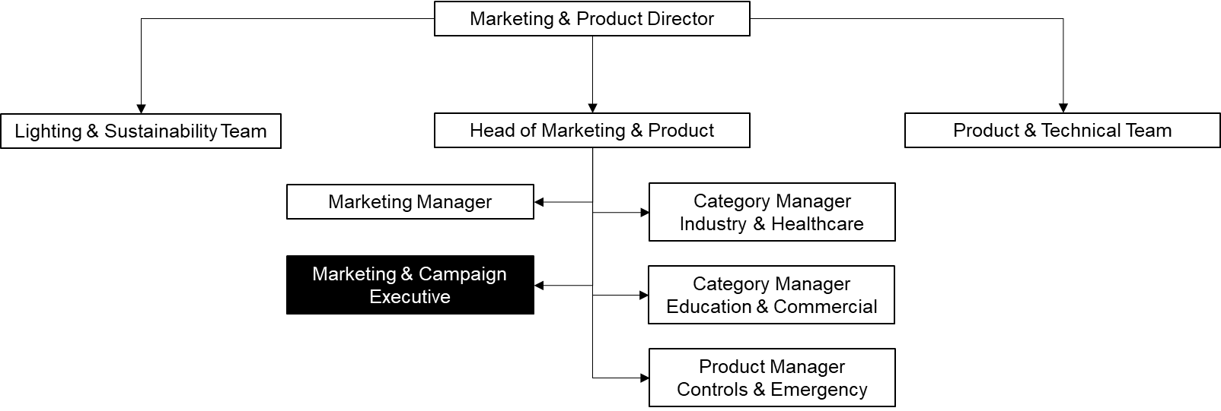
Purpose of the Position
To create, plan and deliver effective marketing campaigns that will support the achievement of business objectives and drive brand awareness, lead generation and customer engagement activities.

Key Responsibilities
Strategy | Working in collaboration with key stakeholders to determine and deliver marketing campaigns to support the achievement of business strategy.
Measuring Effectiveness | Monitoring and measuring effectiveness of marketing campaigns, and producing insights that are used to achieve improvements in the future.
Partnerships | Building relationships and effectively managing external partners, including digital, creative and PR agencies, to deliver successful campaigns and meet marketing and business objectives.
Internal Communications | Delivering internal communication plans, actively promoting Whitecroft’s business culture to both customers and staff, and coordinating employee engagement activities (Workplace, Social Club events, fundraising and annual events).
Customers | Supporting the delivery of customer engagement comms, defining and creating automated workflows to support the customer journey and optimising the customer experience both online and offline.
Product | Working in collaboration with the Category and Product Managers to implement effective marketing campaigns and to ensure a successful product launch to both internal and external target audience.
Integrated Comms | Supporting the delivery and promotion of key activities, for example Thought Leadership strategy, by producing high quality and consistent marketing content for a range of online and offline channels: events, tradeshows, social media, video, email, website etc.
Brand | Supporting the overall brand strategy and positioning, coordinating brand support activities, and providing clear brand guidelines.

Specific Skill Requirements
 | Essential | Desirable
Education / Technical Skills | - A degree in Marketing, Digital Marketing, Communications, Public Relations, or equivalent qualification  - 2+ years of experience in a B2B commercial lead generation marketing role  - Experience in running regular marketing campaigns incl. product and service propositions  - Capable of monitoring, evaluating, and driving success from campaigns  - Practical knowledge of marketing automation software, ideally HubSpot, to generate leads and build customer databases  - Practical knowledge of digital marketing channels and tools, including social media, SEO, CMS and Google Analytics  - Project management experience | The Chartered Institute of Marketing (CIM) professional certificate/diploma in marketing  Experience in the manufacturing, electronics, or lighting industries  Multi-channel marketing experience  Experience using Adobe Creative Cloud and Canva
Behaviour | - Excellent written, verbal, and interpersonal communications skills  - Positive, can-do attitude and willingness to use initiative  - Demonstrates a high level of attention to detail  - Ability to work in collaboration with key stakeholders to ensure the tasks are completed  - Demonstrates ability to be commercially aware  - Is influential, with the confidence to make  timely decisions.  • Strong organisation and time management skills with flexibility to accommodate change | Willingness to up-skill and enhance knowledge through any training requirements.  Passionate about marketing and interested in pursuing a marketing career.

Written By: | Marcelina Fila | Date: 23.01.2023

